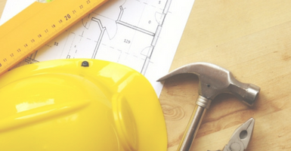

OHBA Queen's Park Advocacy Day
On May 28th, 20+ Home Builders' Association's met at Queen's Park to speak with MPPs about provincial and local housing market perspectives, Bill 108 - Housing Supply Action Plan, Closing the Skills Gap/Skilled Trades and Construction Liens. OHBA's #weneed1MILLIONhomes campaign was front and center during discussions.
Industry
Review of Tarion’s Construction Performance Guidelines
From now until July 22, 2019, Tarion is actively seeking feedback on the Phase 2 (Spring 2019) proposed revisions to the CPG...Read More
OHBA
Awards of Distinction
Two days left to save on your entry fees (register by May 31) + How to take the best photos for your entry...Read More
CHBA
Webinar
Registration is still open for the June 4th "How Municipalities Can Enable Net-Zero Construction" webinar...Read More

Questions? email thall@gbtel.ca
Grey Bruce Home Builders and Trades Association Inc.
Our mailing address is: P.O. Box 266, Owen Sound, ON N4K 5P3

