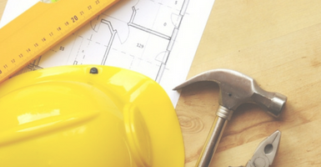

IMPACTS OF BILL 108
BILD and OHBA have produced a series of short videos to help members understand the impacts of Bill 108 on our industry, as follows:
Video 1: Impact of the proposed changes to the LPAT, with David Bronskill of Goodmans LLP.
Video 2: Impact of Schedule 4 to the Education Act, with Denise Baker of Weir Foulds LLP.
Video 3: Overview of the changes to the Growth Plan, with Matthew Cory of Malone Given Parsons.
Video 4: Proposed changes to the Ontario Heritage Act, with Mark Flowers of Davies Howe LLP.
Video 5: Impacts of proposed changes to development charges, parkland dedication and community benefit charges, with Denise Baker of Weir Foulds LLP.

Questions? email thall@gbtel.ca
Grey Bruce Home Builders and Trades Association Inc.
Our mailing address is: P.O. Box 266, Owen Sound, ON N4K 5P3

